For immediate release
With Class-Leading Levels of Power, Capability and Technology, the 2021 F-150 Offers Owners Exceptional Performance and Value

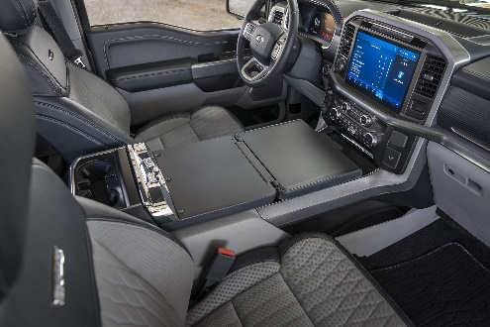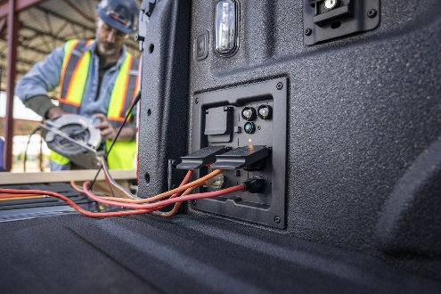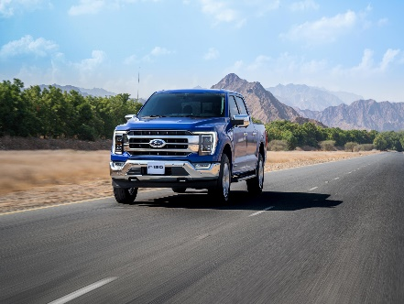

DUBAI, UAE, 14 July 2021 – The Ford F-150 has established itself as a firm favourite with truck enthusiasts in the region with capability, technology and safety technologies that continue to raise the bar in the light-duty truck segment.
But the engineering and design team behind the all-new F-150 wasn’t satisfied with settling on past achievements and set about making the 2021 truck the toughest, most productive and smartest F-150 Ford has ever built.
While all-new F-150 still features a durable, proven foundation – a fully boxed high-strength steel frame with a high-strength, military-grade, aluminium alloy body – every panel of the distinctive, rugged exterior was redesigned for 2021. The bold and tough signature look includes an updated headlamp design, new power dome hood and wrap-around bumpers. Higher front fenders, a tucked-in midsection, wider stance and larger-diameter tyres create a stronger, more powerful presence on and off the road.
The F-150’s winning combination of great design and elevated levels of standard equipment mean that owners can get more done with more capability and with more convenience than ever before.
More equipment as standard
Every Ford F-150 comes with a generous list of equipment as standard. Ford’s Co-Pilot 360 offers features often bundled at an extra cost by other manufacturers, and includes next level safety and convenience features like Rear View Camera with Dynamic Hitch Assist; Reverse Sensing System; Auto-High Beam; Lane-Keeping System with Lane-Keeping Aid, Lane-Keeping Alert and Driver Alert System; Pre-Collision Assist with Automatic Emergency Braking (AEB), Pedestrian Detection and Forward Collision Warning with Dynamic Brake Support.

More power as standard
With a choice of four engines, F-150 delivers the performance, fuel economy and power owners expect.
The legendary 5.0-litre V8, with twin independent variable cam timing (Ti-VCT) and port-fuel and direct-injection (PFDI), delivers a robust 400 horsepower and 555 Nm torque, giving it a best in class maximum payload rating of 1508kg. And, with new Variable Displacement Engine (VDE) technology, the engine is able to shut down half of its cylinders when full power is not needed.
The 3.5L EcoBoost V6 develops 400 horsepoer and 677 Nm. of torque, handing the truck best-in-class available tow rating of 6,350 kg. The engine accomplishes this by using Ford’s port-fuel and direct-injection (PFDI) system with two injectors per cylinder, and twin intercooled turbos for on-demand power with virtually no lag.
All F-150 variants come fitted with an advanced 10-speed automatic transmission which has been developed to produce impressive overall performance, with enhanced acceleration at the low and mid ranges of the power band. Features include optimised wide-span gear spacing coupled with drag-reduction actions plus three overdrive gears.
Class-exclusive hybrid power
The all-new class-exclusive 3.5L PowerBoost Full Hybrid V6 powertrain combines the strength of the turbocharged 3.5L petrol engine and a 44-horsepower (33-kW) electric motor, regenerative braking and a lithium ion battery to create a hybrid system designed to boost both power and efficiency. The new hybrid powertrain’s 430 horsepower and
772 Nm of torque is unequaled by any competitor in the segment.

Power on the go
With 2.3 kilowatts of exportable power, owners with Pro Power Onboard equipped full hybrid F-150s can leave the generator behind and tap into electrical power accessible via in-cabin outlets and the cargo bed-mounted sockets. Owners can monitor the system on the productivity screen in the centre of the dash. Pro Power Onboard operates when the vehicle is parked or in motion which means you can charge items while you’re driving to your camp or worksite. And, once you get there, you can tap into the power outlets in the truck bed to get started on a project, or set up the ultimate campsite.

All-New Interior
The F-150 interior was designed with owners in mind. In fact, Ford’s research and development teams spent hundreds of hours with owners to see just how each of them used their trucks – then designed convenience features around these real-world scenarios.
The result is materials and colour choices that are more upscale. There is more storage, more comfort and more functional features that make living with the truck far more convenient. The new instrument panel now includes standard 8-inch and available 12-inch centre-stack colour touchscreens; while the available fold-out work surface gives owners a handy place to use their laptops, make notes or even have lunch.
Class-exclusive Max Recline Seats available on Platinum and Limited models provide ultimate comfort during downtime. Max Recline Seats fold flat to nearly 180 degrees, with the bottom cushion rising to meet the back cushion and the upper back support rotating forward up to 10 degrees for maximum comfort.
Available lockable, fold-flat rear storage adds a vault to the F-150 that extends the width of the rear seats. It’s as easy as lifting the bottom cushion of the rear seat, dropping valuables in and locking them away for safe keeping.
Smarter technology
All-new SYNC 4 debuts in the F-150 and is standard across all trim levels, helping keep owners connected and make their days more productive with more natural voice control available as well as customisable information on demand. The technology builds on more than 10 years of SYNC innovation by helping minimise distractions with hands-free voice control as well as core features such as making phone calls and selecting music. With twice the computing power of the previous-generation system, new SYNC 4 can wirelessly connect smartphones without the USB cord for seamless integration of Apple CarPlay™ or Android Auto™ compatibility as well as SYNC AppLink® apps like Waze.
The new eight-speaker B&O Sound System by Bang & Olufsen is available starting on F-150 XLT, while the optional 18-speaker B&O Unleashed system with speakers in the headliner and front headrests is standard on F-150 Lariat, Platinum and Limited.
Driver-assist technologies
All-new F-150 offers the latest driver-assist features as part of Ford Co-Pilot360™ 2.0. More features are now standard on XL, including Pre-Collision Assist with Automatic Emergency Braking and Pedestrian Detection to help avoid a possible collision with another vehicle or a pedestrian, rearview camera with dynamic hitch assist, auto high-beam headlamps and auto on/off headlamps.
F-150 also adds 10 new driver-assist features that include Intersection Assist, which detects oncoming traffic while the driver is attempting a left turn. If there is risk of a collision with an oncoming vehicle, F-150 will apply the brakes to mitigate or avoid it. F-150 is the only light-duty full-size pickup with available Active Park Assist 2.0, which handles all steering, shifting, braking and accelerator controls during a parallel or perpendicular parking maneuver while the driver simply holds down a button.
The all-new 2021 F-150 is available in showrooms across the region. Visit me.ford.com for more details.
# # #

About Ford Motor Company
Ford Motor Company (NYSE: F) is a global company based in Dearborn, Michigan, that is committed to helping build a better world, where every person is free to move and pursue their dreams. The company’s Ford+ plan for growth and value creation combines existing strengths, new capabilities and always-on relationships with customers to enrich experiences for and deepen the loyalty of those customers. Ford designs, manufactures, markets and services a full line of connected, increasingly electrified passenger and commercial vehicles: Ford trucks, utility vehicles, vans and cars, and Lincoln luxury vehicles. The company is pursuing leadership positions in electrification, connected vehicle services and mobility solutions, including self-driving technology, and provides financial services through Ford Motor Credit Company. Ford employs about 186,000 people worldwide. More information about the company, its products and Ford Motor Credit Company is available at corporate.ford.com.

Contacts: | Rania Al-Shurafa  Communications Manager  Middle East |  | Jemma Chalcroft  Associate Director  ASDA’A BCW
 | 00971-50-362-7791 |  | 00971-55-614-6441
 | rania.shurafa@ford.com |  | jemma.chalcroft@bcw-global.com

